Quiz 01

- Consider silicon at 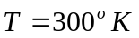doped with phosphorus at a concentration of 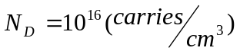. Calculate the thermal equilibrium electron and hole concentrations.
Ans: 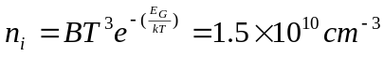
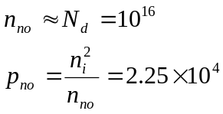
- Consider a silicon PN junction at doped at 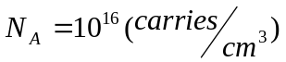 in the p-junction and 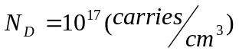 in the n-junction. Calculate the different potential at PN-junction.
Ans: 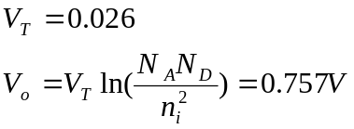
- Consider a silicon PN junction at with doping concentration of and 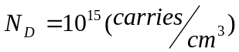. Assume 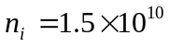 and let 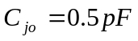. Calculate the junction capacitance at 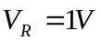 and 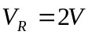.
Ans: 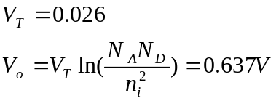
Consider the case of
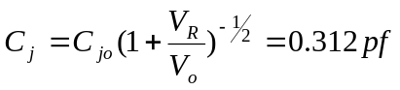
Consider the case of 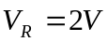
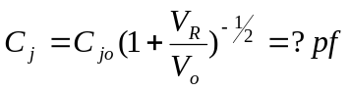
- Consider a N-type silicon at with doping concentration of . Assume the charge density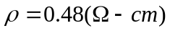. Find the mobility of electron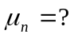.
Ans: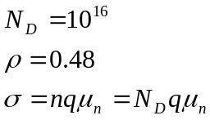
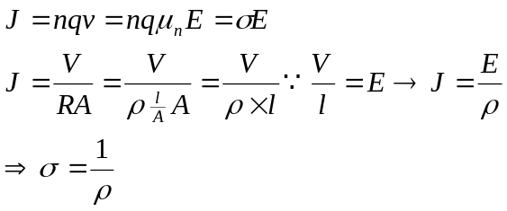
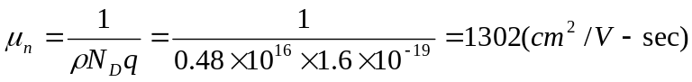
- Consider the following three impure silicon semiconductor samples:

 | Doped B element | Doped P element
Sample A | Concentration 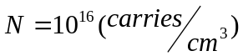
Sample B |  | Concentration
Sample C | Concentration | Concentration
Calculate the conductivity of these three samples.
Ans: